Case 6-Nigeria Ife Bust —Late 20th Century   
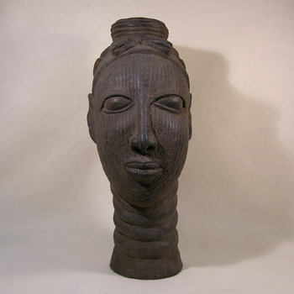  
Large gray terracotta female bust. Obviously a modern reproduction modeled after originals found at the great Yoruba center at Ife dating to 1100-1450 A.D. This clay head is of an Oni, the ruler at Ife, who still holds power over the Yoruba people at Ife today. A nice decorative piece in excellent condition.   
  
Just over 16" tall   
  
$225